2025/26
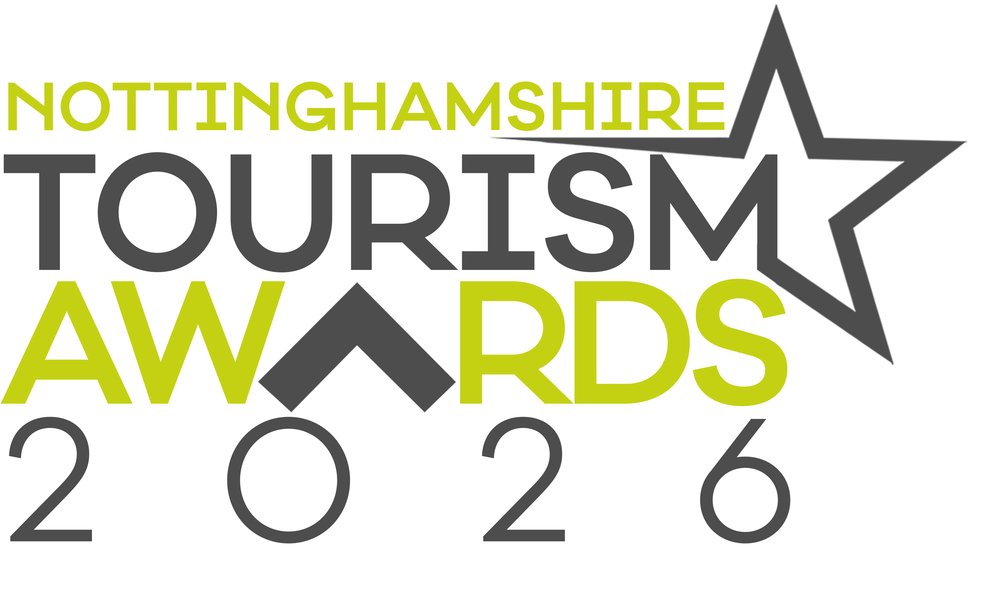
Festival or Event
of the Year

Recognises providers of truly memorable and immersive
Tourism festivals or events

Eligibility Criteria
Recognises providers of truly memorable and immersive festivals or tourism events which attract a wide range of visitors or appeal to a niche market bringing substantial benefits to the local visitor economy.

Festivals or Events which occurred between 01 June 2024 and 31st May 2025 are eligible to apply

Directly involved in tourism, making a contribution to the visitor economy with a significant proportion of business generated by people visiting from outside the local area.

The festival or event can be for either a paid entry or free audience/attendance event. The festival or event can be a one off or an annual event with a proven track record. It should be noted that the supporting evidence in the submissions for this category are particularly important as any final assessment will be retrospective.

Judges will be looking for evidence of innovation and a sense of distinctiveness that adds to an event’s appeal to the visitor. Please also provide evidence of the profile this brings to the local community and the contribution the event makes to the area.

Round 1 judging will determine a shortlist of festivals and events are open to a public vote.

Round 2 judging will be a public vote which will determine the Gold, Silver and Bronze winner.

Applicant & business details
(not scored)
Applicant’s name:
Enter the applicant’s name here.

Applicant’s job title:
Enter the applicant’s job title here.

Applicant’s phone number:
Enter the applicant’s phone number here.

Applicant’s email:
Enter applicant’s email here.

Event name:
Name of event application relates to. Give the name used to promote the event, as you wish it to appear in all publicity materials, on certificates, in presentations etc.:
Enter your event name here.

Event address:
Enter your event address here.

Event Dates (date(s) the festival or event took place):

Number of years event has been running:

No of staff

Enter the number of staff here.

Promotional Description
Provide a promotional description of your event.
- Focus on its strengths and stand out features
- Write your description with regard to this category
- This wording will be used in PR and awards literature if you are short listed as a finalist
- Wording provided is subject to edit
- 120 word maximum
Enter the promotional description here.

Promotional Images
Provide up to three landscape high resolution photos.
- Photos should relate to this category
- Photos should not be edited in any way e.g. embedded text or logos, a collage
- Only include photos that you own the copyright for
- If the photo requires a third-party credit e.g. photographer, please provide details
- These photos will be used in PR and awards literature if you are short listed as a finalist

Background
(not scored)
Briefly outline the story of your event (250 words maximum).
For example:
- Length of time event has been running
- Target market(s) and typical customer profile
- Key milestones in developing the business
- Indication of size of business
- Number of staff employed, if any
Enter information on the background of your business here.

List any awards, ratings, and accolades received in the last two years. Include the title, awarding body, level and date achieved.
For example:
- Successes in this competition and the VisitEngland Awards for Excellence
- TripAdvisor Certificate of Excellence
- Green Tourism award
- VisitEngland and/or AA quality assessment, local quality accreditation

Enter information on any awards, ratings or accolades here.

There is no requirement for your business to be quality assessed. However, if you have an independent quality assessment/mystery shopping report from the last two years, you might wish to attach it when emailing your completed application form /upload it here (optional).

Online presence & reviews
(this section is 30% of the final score)
Provide links to your online presence, which will be reviewed and scored by judges in addition to your answers to the four questions. Other sites may also be checked.
As part of this review, judges will be looking for evidence of your commitment to Accessible and Inclusive Tourism and Ethical and Responsible and Sustainable Tourism.
Website (10%)
Enter the website URL here.

Provide links to all business pages / profiles on Facebook, Instagram etc, and Twitter handles.
Enter the social media URL here.

Accessibility & inclusivity information (Provide links to your accessibility and inclusivity information.)
Enter the accessibility & inclusivity information URL here.

Sustainability information (Provide links to your sustainability information.)
Enter the sustainability information URL here.

Online review sites (10%)
Provide specific links to customer review listings for your business e.g. TripAdvisor, Booking.com, Google, Upfront Reviews, My Cottage Holiday, Euan’s Guide
Enter online review sites here.

Question 1 - Your Top Qualities
(this question is 20% of the final score)
Tell us about up to five ways in which your event is impressive compared to your competitors (500 words maximum).
Describe the unique selling points, strengths and essence of you business. One or more of the following example areas may be relevant to address in your answer (it is not mandatory to cover every area):
- Quality of your core product and customer experience
- Added extras that delight your customers
- How you care for your team
- Details of your events programmes / exhibition / performance.
- Innovative marketing and PR, including partnerships with other businesses
- Facilities and welcome for people with a range of accessibility requirements
  - For example, this may include information provision, adapted customer experiences, accessible facilities for people with a range of impairments and staff disability awareness training
- Managing and improving environmental, social and economic impacts
  - For example, this may include a carbon reduction plan, energy and waste monitoring, green transport, community initiatives and responsible purchasing
- Innovative adaption, diversification and resilience building.
Enter answer to question 1 here.

Links to relevant supporting evidence online (optional):
It is not a requirement to submit supporting evidence; however, if you do, ensure that the focus is on the quality and relevancy of the evidence submitted rather than quantity . Any written answers that are included within the supplementary evidence, attempting to circumvent the question word counts, will be disregarded.
Enter links to supplementary evidence here.

Question 2 – Event Development
(this question is 20% of the final score)
Tell us about up to five ways in which you have developed your event and/or improved the customer experience over the last two years (500 words maximum).
Explain your reasons for making the improvements and indicate which parts of the business are impacted. One or more of the following example areas may be relevant to address in your answer (it is not mandatory to cover every area):
(Only include examples of improvements undertaken in the last two years.)
- Promotional initiatives e.g. new website
- Improving the skills of you and your team
- Expansion, upgrade of facilities, enhancements to your services
- Facilities and welcome for people with a range of accessibility requirements
  - For example, this may include information provision, adapted customer experiences, accessible facilities for people with a range of impairments and staff disability awareness training
- Managing and improving environmental, social and economic impacts
  - For example, this may include a carbon reduction plan, energy and waste monitoring, green transport, community initiatives and responsible purchasing
- Innovative adaption, diversification and resilience building
- Reasons for making the improvements e.g. driven by customer feedback
- Approximate date of improvement

Enter answer to question 2 here.

Links to relevant supporting evidence online (optional):
It is not a requirement to submit supporting evidence; however, if you do, ensure that the focus is on the quality and relevancy of the evidence submitted rather than quantity.
Any written answers that are included within the supplementary evidence, attempting to circumvent the question word counts, will be disregarded.
Enter links to supplementary evidence here.

Question 3 - Your Results
(this question is 15% of the final score)
Thinking of how you measure success, tell us about three successes from the last year (300 words maximum).

One or more of the following example areas may be relevant to address in your answer (it is not mandatory to cover every area):
- Whether you are able to attribute success directly to any of the improvements that you’ve made (mentioned in Question 2)
- Percentage increase in occupancy levels/visitor numbers, sales, customer satisfaction and wastage reduction
- Percentage increase in online bookings
- Increase in repeat business
- Business generated from marketing activity
- Growth of social media following and engagement
- The significance of the level of impact on your business

Enter answer to question 3 here.

Links to relevant supporting evidence online (optional):
It is not a requirement to submit supporting evidence; however, if you do, ensure that the focus is on the quality and relevancy of the evidence submitted rather than quantity.
Any written answers that are included within the supplementary evidence, attempting to circumvent the question word counts, will be disregarded.
Enter links to supplementary evidence here.

Question 4 – Your Future Plans
(this question is 15% of the final score)
Tell us about three ways you will develop and promote your event experience over the next year and the reasons why (300 words maximum).
One or more of the following example areas may be relevant to address in your answer (it is not mandatory to cover every area):
- Continued adaption, diversification and resilience building
- Facilities and welcome for people with a range of accessibility requirements
  - For example, this may include information provision, adapted customer experiences, accessible facilities for people with a range of impairments and staff disability awareness training
- Managing and improving environmental, social and economic impacts
  - For example, this may include a carbon reduction plan, energy and waste monitoring, green transport, community initiatives and responsible purchasing
- Expansion, upgrade of facilities, enhancements to your services
- Improving the skills of you and your team
- Marketing and PR, including partnerships with other businesses
- Operational efficiency

Enter answer to question 4 here.

Links to relevant supporting evidence online (optional):
It is not a requirement to submit supporting evidence; however, if you do, ensure that the focus is on the quality and relevancy of the evidence submitted rather than quantity.
Any written answers that are included within the supplementary evidence, attempting to circumvent the question word counts, will be disregarded.
Enter links to supplementary evidence here.

